**Background**

Road accidents are on a rise throughout the world. Whenever an accident occurs, a lot of features describing it are captured like light conditions, weather conditions, road surface conditions and geographical location, to name a few. Converting such a dataset to a multilayer network will allow one to understand the effect of different combinations of features by addressing important questions like the most dominant factor, accident prone regions with respect to different factors and so on.

Here we present different **homogeneous multilayer networks** that have been built based on the road accidents that occurred in the United Kingdom in the year 2014 (Source: <https://data.gov.uk/dataset/cb7ae6f0-4be6-4935-9277-47e5ce24a11f/road-safety-data>).

**Metadata**

The important attributes describing each accident are as follows

|  |  |  |
| --- | --- | --- |
| Attribute Index | Attribute Name | Attribute Description |
| 2 | Longitude | Part of the accident location |
| 3 | Latitude | Part of the accident location |
| 4 | Accident Severity | Domain – 1: Fatal, 2: Serious, 3: Slight |
| 5 | Number of Vehicles |  |
| 6 | Number of Casualties |  |
| 7 | Date |  |
| 8 | Day of Week | Domain – 1: Sunday, 2: Monday, 3: Tuesday, 4: Wednesday, 5: Thursday, 6: Friday, 7: Saturday |
| 9 | Time | 24 hour clock |
| 10 | Road Type | Domain - 1: Roundabout, 2: One way street, 3: Dual carriageway, 6: Single carriageway, 7: Slip road, 9: Unknown, 12: One way street/Slip road, -1: Data missing or out of range |
| 11 | Speed limit |  |
| 12 | Light Conditions | Domain - 1: Daylight, 4: Darkness - lights lit, 5: Darkness - lights unlit, 6: Darkness - no lighting, 7: Darkness - lighting unknown, -1: Data missing or out of range |
| 13 | Weather Conditions | Domain - 1: Fine no high winds, 2: Raining no high winds, 3: Snowing no high winds, 4: Fine + high winds, 5: Raining + high winds, 6: Snowing + high winds, 7: Fog or mist, 8: Other, 9: Unknown, -1: Data missing or out of range |
| 14 | Road Surface Conditions | Domain - 1: Dry, 2: Wet or damp, 3: Snow, 4: Frost or ice, 5: Flood over 3cm. deep, 6: Oil or diesel, 7: Mud, -1: Data missing or out of range |
| 15 | Urban or Rural Area | Domain – 1: Urban, 2: Rural, 3: Unallocated |
| 16 | Did Police Officer Attend Scene of Accident | Domain – 1: Yes, 2: No, 3: No - Accident was reported using a self-completion form (self rep only) |

**Multiplex Downloads**

*Multiplex Description*

We have generated 4 layers for each accident homogeneous multilayer network. An accident instance is denoted by a node. Being a homogeneous multiplex, the same set of nodes (accidents) is present in each layer. The existence of an edge between two nodes in each layer will be dictated by whether they are similar with respect to the corresponding feature. The layer wise description is as follows.

|  |  |  |  |
| --- | --- | --- | --- |
| Layer ID | Feature/Layer Name | Edge Type | Description |
| 1 | Light Condition | Unweighted, Undirected | Connected accident pair occurred during similar light conditions |
| 2 | Weather Condition | Unweighted, Undirected | Connected accident pair occurred during similar weather conditions |
| 3 | Road Surface Condition | Unweighted, Undirected | Connected accident pair occurred on roads with similar surface conditions |
| 4 | Distance (3 layers based on distance similarity threshold = 10, 20, 50 miles) | Unweighted, Undirected | Connected accident pair occurred within *10, 20 or 50 miles*  of each other (3 different layers) |

*Layer File Format*

In the dataset, each layer is a separate file which is represented in the following manner

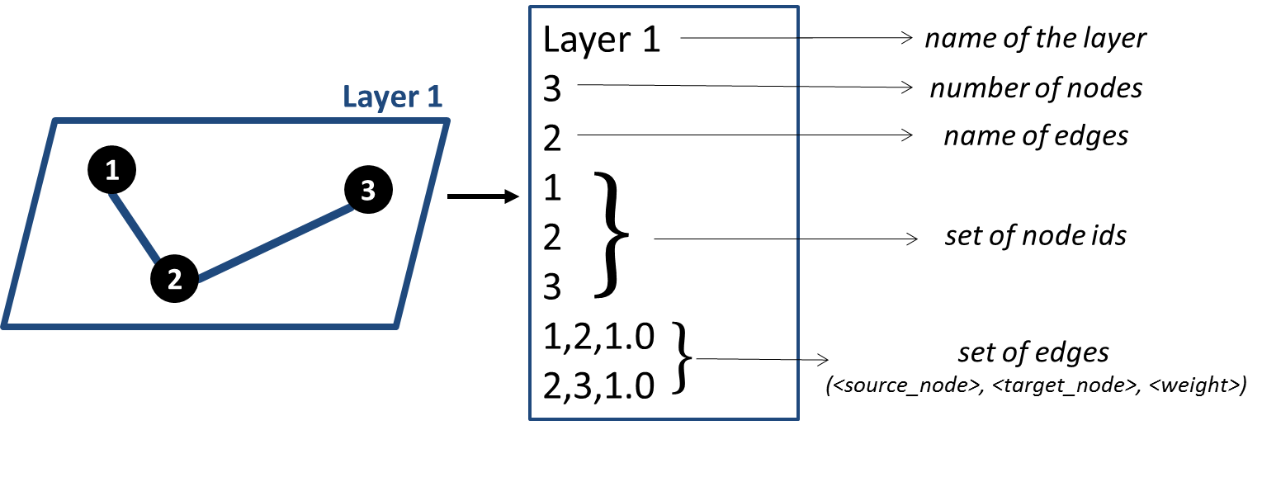

For undirected layers, only one copy of edge is stored in the file. For unweighted layers, a default weight of 1.0 is added to the existing edges.

**P.S.: The content for all the above headings is hidden by default. Only when the user clicks on a particular heading, the content for only the selected heading is visible.**

**The following heading/search bar is always visible**

*Download Links: Select Number of Nodes (Search mechanism comes here - drop down list must have the options for 100, 500, 1000, 2000 and 5000 nodes. Depending upon the selection, the panel below displays the details corresponding to the selection)*

* 100 nodes

*Dataset:* Link 1 *Counter for number of downloads*

This dataset is built using 100 random road accidents that occurred in the UK in 2014. Thus, each layer has same set of 100 nodes. Additional layer-wise details are as follows

|  |  |  |
| --- | --- | --- |
| Layer ID | | Number of Edges |
| 1 | | 3001 |
| 2 | | 3309 |
| 3 | | 2953 |
| 4 | Threshold = 10 miles | 91 |
| Threshold = 20 miles | 218 |
| Threshold = 50 miles | 771 |

* 500 nodes

*Dataset:* Link 1 *Counter for number of downloads*

This dataset is built using 500 random road accidents that occurred in the UK in 2014. Thus, each layer has same set of 500 nodes. Additional layer-wise details are as follows

|  |  |  |
| --- | --- | --- |
| Layer ID | | Number of Edges |
| 1 | | 73422 |
| 2 | | 84299 |
| 3 | | 69049 |
| 4 | Threshold = 10 miles | 2958 |
| Threshold = 20 miles | 7229 |
| Threshold = 50 miles | 20639 |

* 1000 nodes

*Dataset:* Link 1 *Counter for number of downloads*

This dataset is built using 1000 random road accidents that occurred in the UK in 2014. Thus, each layer has same set of 1000 nodes. Additional layer-wise details are as follows

|  |  |  |
| --- | --- | --- |
| Layer ID | | Number of Edges |
| 1 | | 283458 |
| 2 | | 336216 |
| 3 | | 281177 |
| 4 | Threshold = 10 miles | 13187 |
| Threshold = 20 miles | 31395 |
| Threshold = 50 miles | 91049 |

* 2000 nodes

*Dataset:* Link 1 *Counter for number of downloads*

This dataset is built using 2000 random road accidents that occurred in the UK in 2014. Thus, each layer has same set of 2000 nodes. Additional layer-wise details are as follows

|  |  |  |
| --- | --- | --- |
| Layer ID | | Number of Edges |
| 1 | | 1139763 |
| 2 | | 1359907 |
| 3 | | 1101883 |
| 4 | Threshold = 10 miles | 52382 |
| Threshold = 20 miles | 118811 |
| Threshold = 50 miles | 341760 |

* 5000 nodes

*Dataset:* Link 1 *Counter for number of downloads*

This dataset is built using 5000 random road accidents that occurred in the UK in 2014. Thus, each layer has same set of 5000 nodes. Additional layer-wise details are as follows

|  |  |  |
| --- | --- | --- |
| Layer ID | | Number of Edges |
| 1 | | 7359310 |
| 2 | | 8444276 |
| 3 | | 7113588 |
| 4 | Threshold = 10 miles | 334381 |
| Threshold = 20 miles | 796682 |
| Threshold = 50 miles | 2191639 |

* Citations
  + Will update this section
* Acknowledgements
  + Abhishek Santra, Dr. Sanjukta Bhowmick, Dr. Sharma Chakravarthy
  + Contact: connectingnetflex@gmail.com